Name: Thi Hong Yen Truong

ID: 614745

ASSIGNMENT 4

Task 1: Home page is the Sign in page as below screenshot

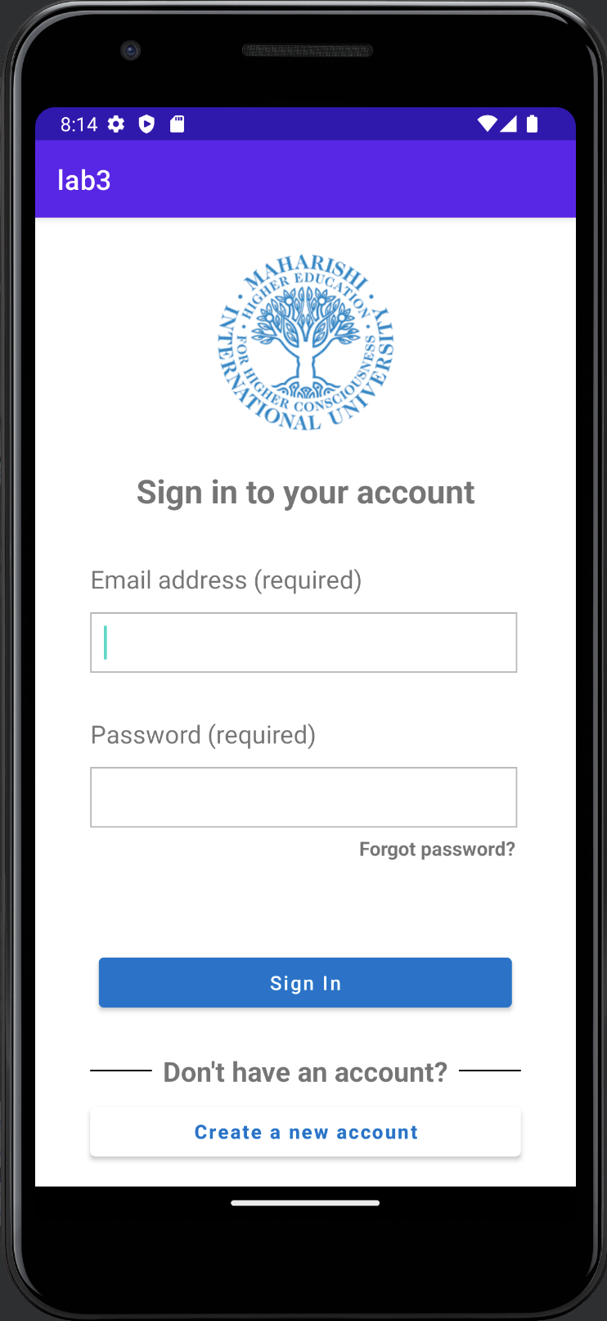

Task 2: Create data class User

Initialize 5 users in MainActivity.kt

Sign in by one of 5 exited accounts above. In my demo, I choose account with email [yt@gmail.com](mailto:yt@gmail.com)

Click in Sign In button, the app does validation for email and password. The app will show message if the Sign In form is invalid, as below screenshot:

Input validation information as below screenshot:

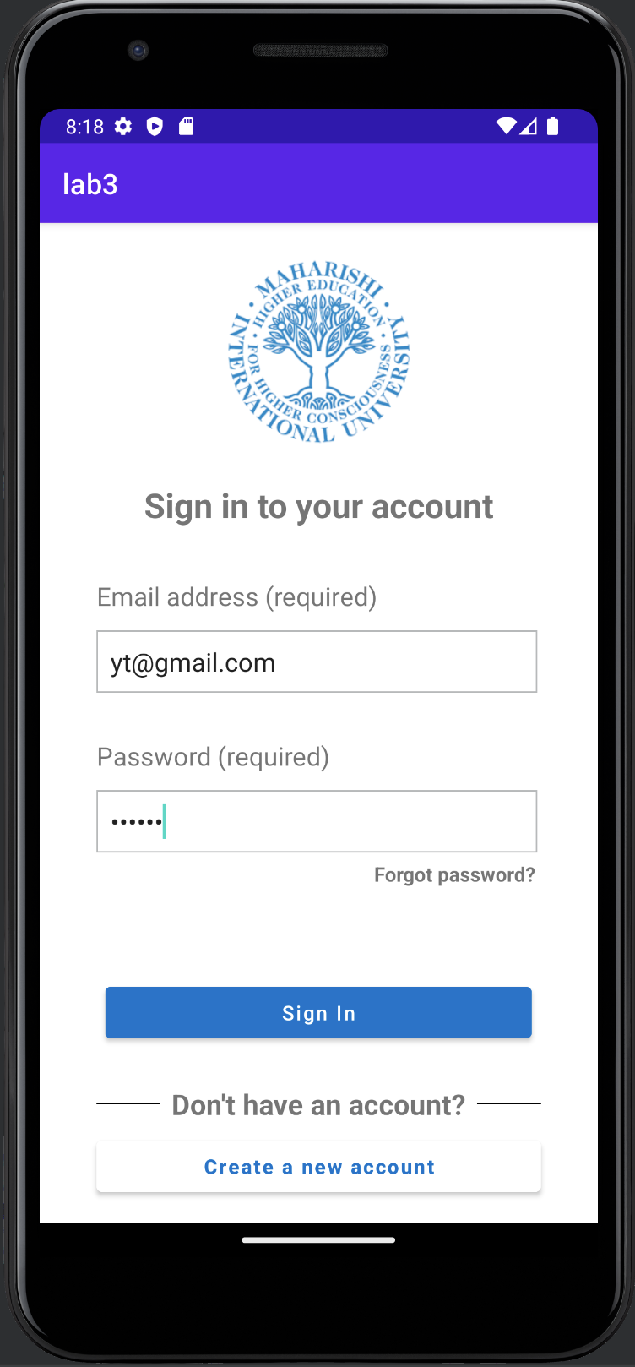

and go to Shopping Categories:

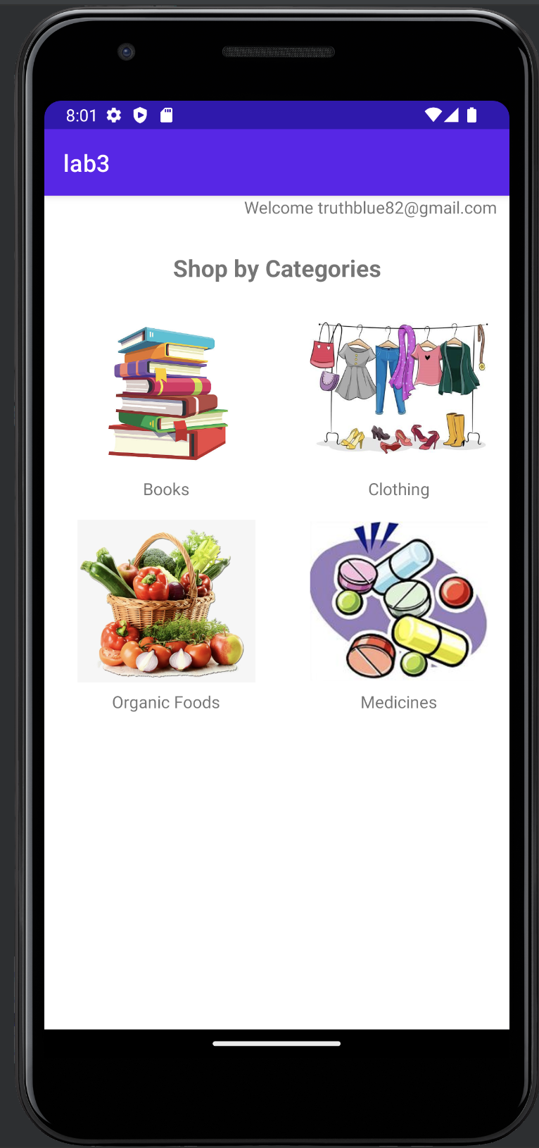

Click in every category in the list categories, the app will show a message as below screenshot:

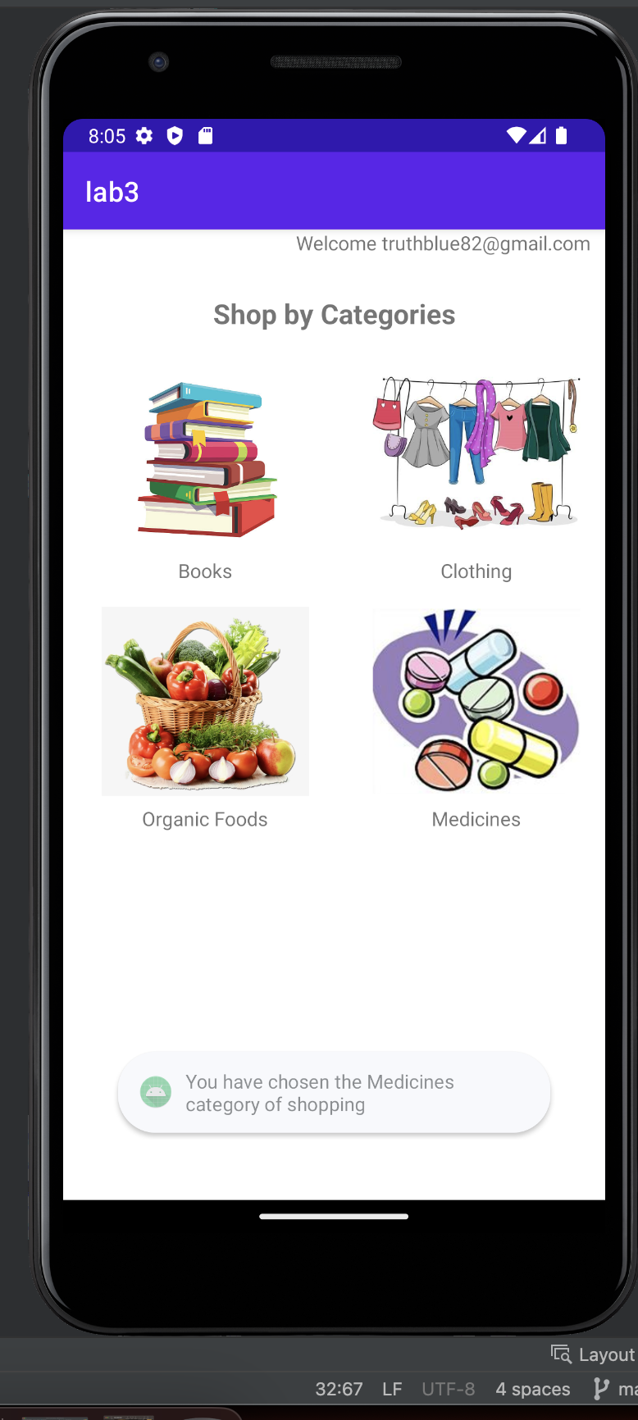

Back to Sign In page, click in Create a new account button to go to Sign up page, fulfil all text view as below screenshot:

Click on Create Account button to create a new User. Hence, the app store new user to array users.

If user forgot password, user input the email, and click in the forgot password link as below image:

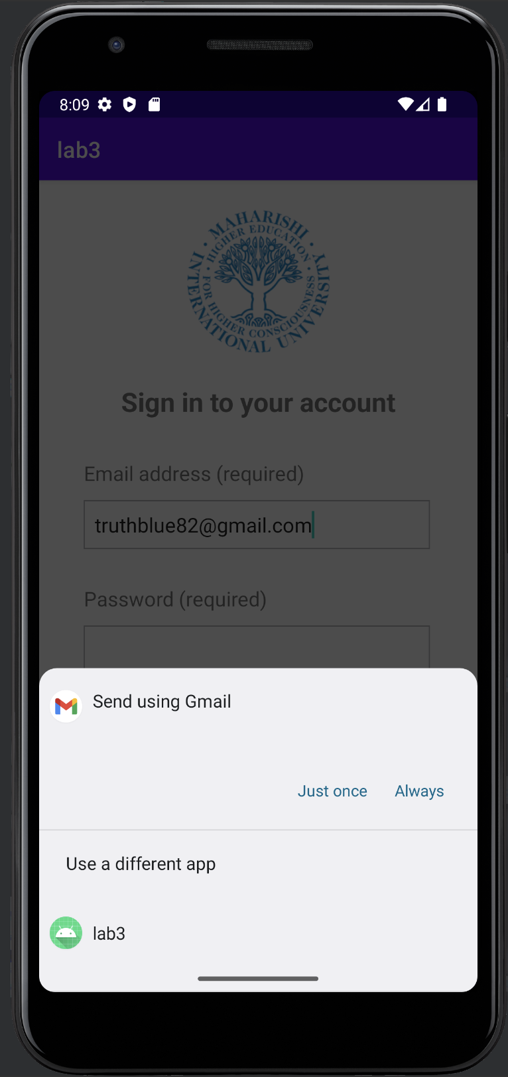

Select Just once or Always, depend on your selection.

The app go to below screen, with default email Subject, and email body as below:

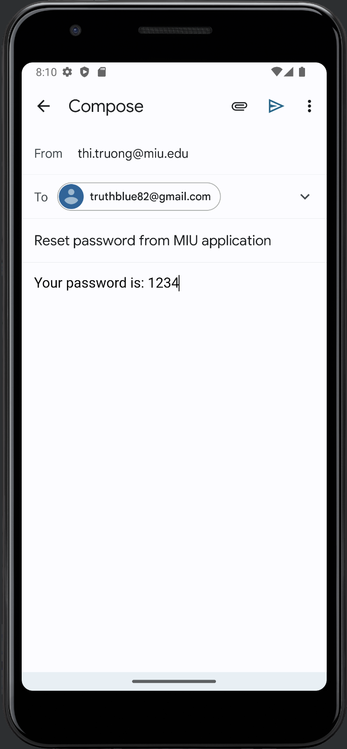

The app finds a user with its email in the array users and get its password to send a forgot password email as below.

Check email of [truthblue82@gmail.com](mailto:truthblue82@gmail.com), I receive the email.

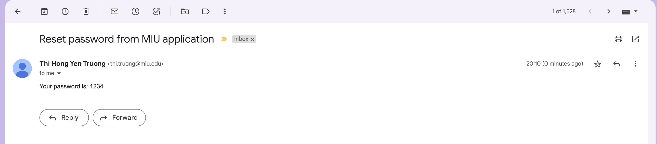

Calculator page layout:

